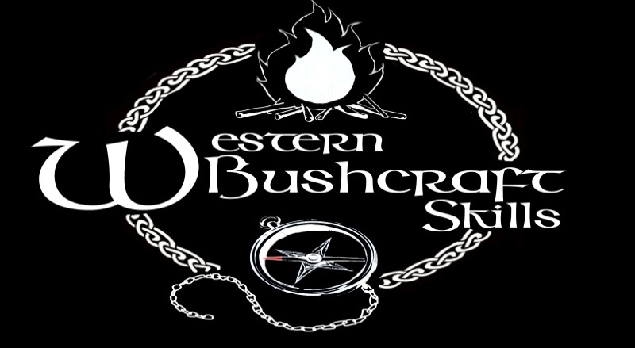
* Please return this form accompanied by deposit to confirm your booking
Child Name(s) | Age(s)
Parent Name:
Contact Email & Phone number:

Additional info/ requirements of participants?

Allergy/ Dietary requirements?

Course time: | 10am- 4:30pm
Course dates (Fill in) | Payment Details (deposits are non-refundable)  €35 per person Postal order, payable to Western Bushcraft Skills.  Return to: Steven Lenihan, New House, Lakeview, Claregalway, Co. Galway.
Bushcraft Summer Camps 2017 | Or  Online payment made to:  Bic: BOFIIE2D  IBAN: IE89BOFI90404262728777  (Please reference your name & date of course)
 | Balances to be paid on the first day of camp by cash or electronic transfer.

